BE READY FOR THE QUESTIONS
COMPLETED EXAMPLE EDITION
Plan the questions. Prepare your talking points. Tell your story clearly.
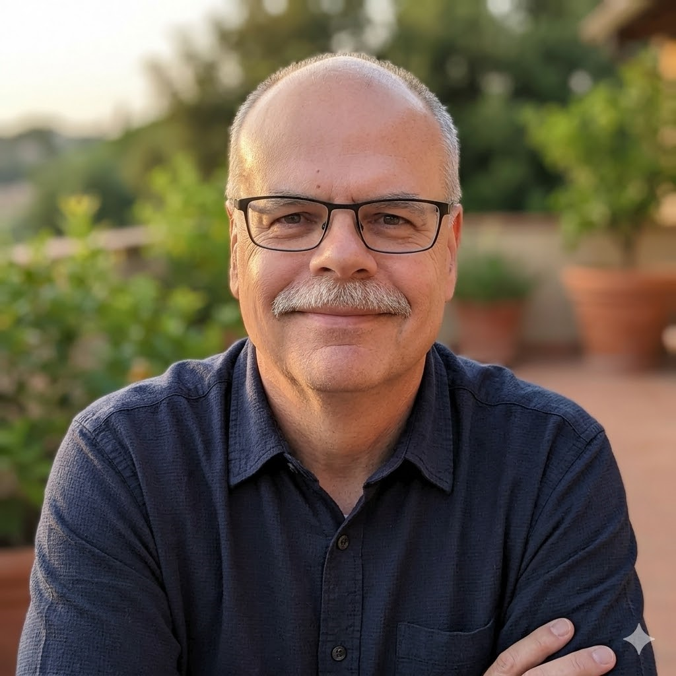 | ABOUT TONY VENTIMIGLIO  Business consultant, sales leader, author and entrepreneur. I have spent my career being accountable for results — building sales organizations, managing operations, developing businesses, improving performance and finding opportunities others overlooked. Today I am applying that experience to consulting, CRM maximization, customer reactivation, publishing, product development and community support. I use real stories and thoughtful preparation to make podcast conversations valuable for listeners.

HOW TO USE THIS EXAMPLE
These 64 questions and notes show how I prepared for an actual podcast conversation. Use them as illustrations of preparation, not as a script to memorize.
The headings reflect my particular background. Your own topics and possible questions will be different.

CORE / OPENING QUESTIONS
# | QUESTION | NOTES / TALKING POINTS
1 | Tony, tell us a little about yourself. | I grew up in a small town in Western Pennsylvania and left in my early 20s. I’ve been married for 31 years and have a 35-year-old daughter. My career was built around service and leadership. I was fortunate to always have outstanding mentors, and that instilled in me the desire to mentor others.
2 | How would you describe what you do today? | Primarily, I’m an author and content creator. I also work a part-time job to get out of the house a bit. I’ve written two books, It’s A Glorious Day and Glorious Days on the Dirt Road. I’ve also developed financial products that I created for myself over the years, tested, revised, and improved. I decided to make those available to others because I think they can help people better control their budgets, learn where to save, and negotiate with vendors like subscription providers.
3 | How did you go from your earlier career and life experiences into writing and publishing? | Cancer played a big role in that. I’ve had cancer for six years, and it became Stage IV nearly four years ago. The treatments are debilitating — fatigue, muscle weakness, and so on. I worked full time until the end of 2024 and part time after that. I still feel like I have things to do, and with the physical limitations, writing and publishing made sense.  I had also journaled for quite a while, and that increased once I was diagnosed with cancer. I write about fear, faith, lessons learned, and staying positive throughout. I try to make each piece cover those things, especially the lessons and the reasons to be grateful.
4 | What does your tagline, “Hard roads. Useful lessons. Keep moving.” mean to you? | Great question. Life can be a hard road. I know mine has been. If you dwell on the difficulty, you miss the lessons. I try to understand what happened, why it happened, and how to do better while staying grateful and continuing to help others.  “Keep moving” is simple. I can sit and feel sorry for myself, or I can continue to live a full life.
5 | Why did you decide to start telling these stories publicly? | There was a period when I was devastated. Even when the prognosis was good, hearing that you have cancer takes your breath away. Then it came back and spread, and for a while I was preparing to die. I was thinking about the end of my life, what would happen to my family, all of it.  I had been journaling through that period, writing about the fear, the anger, the faith, the sleepless nights, and the lessons I was trying to pull out of it. Eventually, I realized that people going through all kinds of hard things feel many of those same emotions. I thought maybe those stories could help somebody feel less alone and remind them that there can still be a rich life ahead. That’s really what led me to share them publicly and eventually turn them into It’s A Glorious Day.

BOOKS / WRITING
# | QUESTION | NOTES / TALKING POINTS
6 | What led you to write It’s A Glorious Day? | There was a period when I was devastated. Even when the prognosis was good, hearing that you have cancer takes your breath away. Then it came back and spread, and for a while I was preparing to die. I was thinking about the end of my life, what would happen to my family, all of it.  I had been journaling through that period, writing about the fear, the anger, the faith, the sleepless nights, and the lessons I was trying to pull out of it. Eventually, I realized that people going through all kinds of hard things feel many of those same emotions. I thought maybe those stories could help somebody feel less alone and remind them that there can still be a rich life ahead. That’s really what led me to share them publicly and eventually turn them into It’s A Glorious Day.
7 | Who did you have in mind when you wrote it? | The books are really for everyone. If you’ve faced setbacks — if you’ve lived life like all of us do — there are things that weigh heavily on you. I wanted people to see that wherever they are today, it isn’t the end. Get up, brush yourself off, and take a step. It’s about the only control we really have.
8 | What is Glorious Days on the Dirt Road about? | I took “the dirt road” from a Sawyer Brown song that talks about staying true to yourself and not taking shortcuts. To me, it means facing life head-on and understanding that even if you’re on a difficult path right now, it can still be okay. Just keep moving.
9 | What does “the dirt road” symbolize for you? | Life isn’t easy, but it’s worth living. Rather than give up, understand what is happening, face it, hopefully overcome it, and always try to come away a better person. Learn and improve.
10 | Why use personal stories instead of simply writing an advice book? | Anybody can give advice. That doesn’t mean they know what they’re talking about. I open up fully. I’m not telling anyone what they should do. I’m telling them what happened to me, how I felt, what I learned, and how I moved ahead.  I’m not trying to convince anyone, but I believe my stories resonate with people in many different stages of life.
11 | Was there a story that was especially difficult to put on paper? | Ray was a lifelong friend, and we maintained a deep connection even though we lived on opposite sides of the country. He passed a couple of years ago, and it often seemed like our lives mirrored each other. We got divorced the same year and shared that experience. We each had heart attacks around the same time and supported one another through that.  He developed stomach cancer about the same time I was diagnosed with Stage IV cancer. His treatments were much rougher than mine. He had most of his stomach removed, chemotherapy, and everything that goes with it.  One Saturday morning he got me up early. He was in Pittsburgh, so if he was up, I guess I was too. He was ecstatic. The day before, he had been told he was cancer-free. About a week later, my phone rang early on another Saturday morning. The caller ID was his, but... it was his daughter. Ray had passed during the night. He had gotten sick a couple of days after we spoke, was rushed to the hospital, and it was sepsis.
12 | What do you hope somebody feels or does after reading your books? | I hope I can help them get through that day. Face what is in front of you. Learn a lesson, find a way ahead, and be grateful for the day, your family, and everything good in your life. I try to inject humor into many of my stories. Life is rough enough. Gotta laugh.  One of my personal tools is a list I call “validations.” I don’t add much to it now, but I did for years. I wrote down moments of beauty, things I had to be grateful for, how God helped me through, and how He delivered when I didn’t know what was coming.  I’ll tell you a story. I was going through a period when I wasn’t making much money and things were hard. Someone hit my truck in a parking lot. I took the insurance money in cash and hadn’t decided whether to repair it yet. Then the transmission went out, and the truck already had high mileage. I decided not to fix it, and that insurance money became the down payment on another vehicle. I think God kept me from doing anything with that money until the time it was really needed.

RESILIENCE / CANCER
# | QUESTION | NOTES / TALKING POINTS
13 | You’ve been through cancer more than once. How has that changed you? | It strengthened my faith and improved my relationships. I decided that the people I love needed the best of me that I could give them — patience, love, support, whatever that meant.  Emotionally, I’m as strong as I’ve ever been. My faith is stronger too. It hasn’t always been that way, and sometimes it still isn’t, but those times are infrequent.
14 | What does “It’s not over until I quit” mean in practice? | I’m a huge Pittsburgh Pirates fan. Always have been. One summer day, I was in my room listening to the game. We lost — our ninth game in a row. Pirates announcer Bob Prince proclaimed, “It’s a glorious day.” I was shocked. How could that be?  His broadcast partner apparently felt the same way and asked him what he was even thinking. Prince replied promptly: every game we lose is another game closer to winning.  That has stuck with me for close to 60 years. What a terrific lesson. Today may be dark, but don’t quit. You have tomorrow.
15 | Do you think resilience is something people are born with or something they learn? | That’s a tough one. I look at my Dad, and he was so resilient and tough that I think he must have been born that way. But he was also shaped by a difficult life. His mother passed away when he was young. He grew up during the Depression. He had it much harder than I ever did.  He was also a great role model for resilience. I called it grinding when I was younger. He worked two jobs, did all the car repairs, did the work around the house. He just kept going. Took the next step.
16 | How do you keep moving when you’re exhausted, afraid or discouraged? | Sleep. No, really. Sometimes you need to rest and recover. Then I read my list of validations. I’ve tuned out as much discouraging noise as I can. I don’t consume much news, and I stay away from arguments on social media.  Those are everyday things, not just things I do on bad days, but I think they make the rough ones easier. My dogs always give me a chuckle. A nice evening with my wife helps. So does a call from our daughter. If I need to, I call her. She’s grown up and developed into a remarkable person.
17 | What has cancer taught you that success never did? | Gratitude. I think I always focused on what was wrong or how to make things better. I don’t do that anymore. Not everything has to be fixed right now, and I don’t need to become consumed by it.  For a while, I attacked cancer. I’d wake up at night, grab my phone, and study articles about new treatment options. I’d use life-expectancy calculators and study clinical trials. I would be worn out instead of rested.  That was how I lived my life: attack and fix. I was pretty successful doing that, but I couldn’t fix this.
18 | Were there times when you genuinely wanted to stop? | No. Not at all. There were times when I didn’t want to face the world, usually for a day or two. But stop? Never.
19 | How do you distinguish resilience from simply pretending everything is okay? | I wouldn’t know how to pretend. I’m pretty transparent to start with. You may be able to pretend for other people, but you can’t lie to yourself. You know the truth.  For me, resilience means continuing to move ahead as often as I can.
20 | What advice would you give someone who has just received life-changing news? | I’m not one for giving advice. I’ll tell you how I handled it: horribly. Most of us do.  The key is not to get overwhelmed. Confide in someone you trust. Focus on the next step, whatever that is. When I was divorced, the next step was finding a home. I didn’t receive much in the way of household items, so I budgeted tightly and shopped yard sales with a much older friend and mentor. He also let me stay with his family for a week until I found a place.  John was never angry, at least not that he let on. He never had a negative word about anything. It’s important to build that kind of circle of friends. I didn’t plan it, but boy, it helped.

PITTSBURGH / FAMILY / WORK ETHIC
# | QUESTION | NOTES / TALKING POINTS
21 | How did growing up around Pittsburgh shape you? | Pittsburgh was a blue-collar town in the ’60s and ’70s. The fathers of most of my friends, as well as members of my extended family, worked in steel mills or factories. The work was hard. The men were direct and no-nonsense. Discipline was an important part of child-rearing for most families. Most men were handy and did their own work around the house too.  There was also a strong sense of community tied to your neighborhood. Neighbors helped each other. They regularly got together in the evenings on someone’s back porch or in their yard. The kids were the same way. I lived in a neighborhood of about 200 homes, and I don’t think there was a child in my age group who wasn’t a friend or at least a very close acquaintance.
22 | What did your father teach you about work? | My Dad was like nobody I ever met, before or since. He worked two full-time jobs — at least by today’s standards. His second job was about 30 hours a week. He did most of the work around the house too, including big jobs like adding a room. I helped him most of the time, including on that project with one of his friends and the friend’s son.  He was tireless. I’ll give you a story, if that’s okay. One summer day, Dad was cutting the grass in the front yard. The power mower stopped running, so I went outside to spend a few minutes with him while he was resting. Well, he wasn’t resting. He was on the ground, sitting up and bending down to reach his foot. Blood was everywhere.  He had moved two angel statues from in front of our Madonna statue so he could mow there, then backed over one of his feet. He argued with me to shut up so I wouldn’t scare Mom and told me to help him up. I screamed anyway and ran to get a neighbor, who talked him into going to the hospital.  When he got out, on crutches, he tried cutting the grass again — pushing the mower with one hand and using the crutch under his other arm. He finally gave up, but not right away. And he wouldn’t let me touch the lawnmower for a few years after that accident.
23 | You’ve said your dad worked two full-time jobs. What did watching that teach you? | The grind. His primary job was seven days a week. He got double time on Sunday and time-and-a-half on Saturday, but you had to have 40 hours in before the weekend.  Same routine: work 11 PM to 7 AM at the GM plant, come home for an hour or so, then off to the second job. Come home from there, clean up, have dinner, and go back to bed for four or five hours of sleep.  When you’re a kid, you look at something like that and accept it as normal. Why would Dad be abnormal? Looking back, it taught me that at work I could always push through more, regardless of how long it took. I turned that into a rule that I didn’t leave with anything unfinished. Nothing waited until tomorrow unless I needed something from someone else.
24 | Are there parts of that old-school work ethic that you think people have lost? | I don’t know if I’d call it lost. Most people I know work hard, but they don’t necessarily prioritize work over everything else the way we did. My job allowed me to provide for my family, and that drove me to work longer hours and grind. Today, people still see work as necessary to support their families, just like I did. I think they’ve simply moved some other things higher on the list of what’s important to them. And looking back, I’m not sure that’s a bad thing.
25 | Has your definition of success changed as you’ve gotten older? | Until I was in my early 50s, I did the same thing as my Dad. I ground it out. I looked to outshine everyone. I volunteered for the worst assignments and kept grinding until I succeeded. That led to promotions, pay increases, and recognition.  But it took a toll — family, health, relationships. Around 2010, my focus changed. It was hard. I took less demanding jobs, and the pay reflected that too. At the end of my full-time career, I looked back and realized I was making less than I made in 1986. But the quality of life was much better.

CRISIS / STARTING OVER
# | QUESTION | NOTES / TALKING POINTS
26 | You’ve had moments when your life changed almost overnight. How did you handle them? | Keep moving ahead. Sometimes you’re doing it in a fog. I relied on instinct until the fog cleared. In some cases, that took months, and you can’t stop living while you wait. So you focus on the next thing, and then the next. Hour after hour. Day after day.
27 | Tell me about the period around your divorce when suddenly everything stopped. | Wow. This one is painful. I’m not going to get into a lot of details, but I found myself living in a friend’s spare bedroom for a week until I found my own place.  I took virtually nothing from the family home except a couch from a spare room, a cooler, and a 13-inch black-and-white TV. I rebuilt from there. Step by step.
28 | What did you learn from having to rebuild your life one decision at a time? | I learned that I couldn’t control everything, and at that point I could control very little. So I jumped into what I could control — furnishing my place, mostly from yard sales, and rebuilding one decision at a time.
29 | Why do you say people shouldn’t try to solve their whole life at once? | At some point it dawned on me that I was where I was. So much depended on the divorce proceedings: how much time I would spend with my daughter, what assets I would lose, what my child support would be, what my quality of life would look like. It was crushing.  And I’m a fanatic planner, so that made it even harder. I had to turn much of that over to my attorney, who was also a personal friend I trusted. At that time I also turned to God, but I had a lot to learn. My independent streak didn’t allow me to find much comfort in God yet.
30 | What does “take the next step” actually look like when somebody is overwhelmed? | The next step is usually something simple. When I was served with divorce papers, I was a wreck. I suddenly didn’t have a place to live, and I had some other serious problems in front of me. A friend took me in, but accepting that kind of help was hard for me too.  Within a week, I found an apartment and moved in with very little furniture. The first step was simply finding shelter. It was something I could focus on, something I could accomplish quickly, and something that gave me a little bit of control back.

STARTING OVER LATER IN LIFE
# | QUESTION | NOTES / TALKING POINTS
31 | Why start a publishing business at this stage of your life? | I’ve kept a journal for some time. When I wrote, it was never just about what happened and how I felt. I searched hard for the lessons. I usually found them and included them. Years later, I was also able to find the humor in many things that had been devastating, so I added those parts to the stories.  Then I got cancer, and then it became metastatic. It was terrifying. Later, I looked at those journal entries the same way. Sometimes I could find humor, but mostly I found gratitude.  I thought about other people going through struggles and believed the lessons might help them. I don’t preach. I explain what happened to me, what I did, what I learned, and where I found humor, gratitude, and faith in God.
32 | Was there a point where you thought, “I’m too old to be learning all this”? | No. I’ve always been confident in my ability to pick things up quickly. My health affects my life in many ways, but learning isn’t one of them. Neither is my ability to sit at my desk for a few hours.
33 | What has surprised you most about learning publishing, websites, AI, digital products and email marketing? | Nothing works the way you expect. Some things are better than expected, but there’s always a challenge at first.  That’s why I created the Dirt Road Tool Directory and the Dirt Road Small Business Success Pack. In the directory, I detail the tools I tried — what worked, what didn’t, why I adopted particular platforms, and more. That way I can help others avoid some of the mistakes, wasted money, and hours that seemed to never end. Both are on my website, tonyvent.com.
34 | What would you say to somebody in their 50s, 60s or beyond who thinks their opportunity to reinvent themselves has passed? | It’s tough to start over at any age. I think the way to look at it after 50 is to set proper expectations. What’s important? What’s nice to have? What can you do without?  The runway is shorter, so you have to accept where you are and build what is possible. What’s possible may change, but having lofty expectations that take longer than you want — or may not be possible anymore — can make rebuilding much harder.
35 | Has starting over later in life been harder or easier than you expected? | I changed my expectations a long time ago. The mortgage-industry collapse hurt us severely. I started over with my own mortgage company and failed.  That’s what I mean about reasonable expectations. I spent our life savings thinking I could hold on until things turned around, but it was a fool’s dream.
36 | What are you trying to build now? | I know that with Stage IV cancer I won’t live forever, and at 68 I’ve lived a pretty good life. I’d like to replace the income from my part-time job so I can quit and devote myself full time to the publishing business.  I’d like to build something that is scaled enough to continue providing extra income after I’m gone. Ideally, I can make it successful enough that my daughter could step in and operate it if she wants — a business set up well enough that it can run without me, with a steady hand and without taking too much time away from her family. I’d hope that would generate income for my wife and daughter.

FAITH
# | QUESTION | NOTES / TALKING POINTS
37 | What role has faith played during the hardest periods of your life? | I won’t say I’ve always been a believer. That would be a lie. I started to follow God when I got divorced, but when things got better, I took the credit and decided I was strong enough.  The same thing happened during the mortgage crash, at least for a time. I had to hit bottom before I learned that my way wasn’t working and turned to God again. I’d say that period is when I truly became a follower of Jesus Christ.
38 | Has cancer strengthened your faith, challenged it, or both? | You get moments of doubt. You think you’ve been abandoned. You continue to pray. God gives you small victories to build on.  I’ve had my share of setbacks, but God has always given me hope and then a path. So I wouldn’t say my faith was fundamentally challenged, although I guess those moments of doubt were a challenge. But I never quit praying.
39 | How do you maintain faith when the outcome is completely outside your control? | Prayer. Listening for answers. Believing there will be an outcome God has chosen, and doing as much good for others as I can along the way.
40 | Is there a difference between faith and optimism for you? | Optimism can be shaken when you don’t get results. My faith tells me the results I’m seeking may not come, but things will still work out.

MONEY STRESS / PRACTICAL TOOLS
# | QUESTION | NOTES / TALKING POINTS
41 | Why did you begin creating financial tools alongside the books? | I learned a lot as a lender, both in consumer finance and mortgage lending. I understood why certain borrowing habits were a direct path to failure. Then I learned it firsthand in 2006, at the beginning of the collapse of the mortgage system. I didn’t practice what I knew because I thought it wouldn’t happen to me.  I created tools that can help people identify wasteful spending they may not even think about. The materials teach them not only how to identify it, but how to find better alternatives for the things they want to keep, how to negotiate with service providers, and how to improve their decision-making. It’s all at tonyvent.com.
42 | Why do you think money stress is so destructive? | It becomes consuming because you don’t know where to turn. Your family is accustomed to a certain lifestyle. You’re terrified that you’re letting them down.  You continue making bad choices for a time, and for some people, eventually the choices are no longer theirs to make.
43 | What do people misunderstand about budgeting or getting control of their finances? | Eventually, tomorrow arrives. The day of reckoning. Something has to give because you no longer have choices.  For many people, myself included, you live with the delusion that you’ll figure it out — get promoted, make more money, whatever the answer is in your particular situation. Until you can’t.
44 | What makes your approach different from another lecture telling people to spend less? | I don’t lecture. I have no reason to believe I should be able to persuade someone I’ve never met. I tell my stories and hope they resonate. I try to build credibility and stay top of mind with my audience, and I introduce my products.  They’re free to make their own decisions without being preached at. My products are priced affordably so anyone can take a small risk. If they learn something, that’s great. They can always return to tonyvent.com and look at my other offerings.
45 | How does your philosophy of “one manageable step at a time” apply to money? | Like everything else, you can only execute so many actions at one time. A plan doesn’t have to be one step — and it shouldn’t be — but you should identify where to start, then build out a series of alternatives after each step that look like a better path.  And keep an open mind. Success in step one may cause you to reevaluate the steps you thought would come later.

COMMUNITY SUPPORT
# | QUESTION | NOTES / TALKING POINTS
46 | What is the Community Support program? | It’s a program that allows nonprofits, churches, schools, community groups, and other organizations to raise money by sharing my books and resources with their supporters. When someone makes a qualifying purchase using that organization’s tracking code, 35% of the sale goes back to the organization or the cause they’re supporting.
47 | Why did you decide to share revenue with community organizations? | I’ve always been involved in community support projects. I volunteered frequently, helped with community cleanups, fundraising, and other local efforts. Cancer has taken away a lot of my ability to do those things physically. This program gives me a way to continue giving back.  I may not be able to show up the way I used to, but I can still build something that helps organizations raise money and support the people they serve.
48 | How does the 35% arrangement actually work? | When someone buys through the program and uses the nonprofit’s tracking code, 35% of that qualifying sale goes back to the nonprofit or the cause they’re supporting. We handle the product and the transaction, and the organization gets its share based on the sales credited to its code.
49 | Who can participate? | Any nonprofit, church, school, youth group, community organization, or similar cause can participate. Individuals and businesses can participate too by nominating a nonprofit or cause they want their purchases to support.
50 | Why would a church, nonprofit, podcast or community group want to be involved? | Because it gives them another way to support their mission without simply asking people for donations. They can share books and resources that may actually help their supporters, and when someone makes a qualifying purchase, 35% goes back to the organization or the cause they’ve chosen. There’s no upfront cost, and it gives them a simple additional way to raise support.
51 | What do you hope this becomes over time? | I hope it becomes a simple, ongoing way for organizations and the people who support them to help good causes without constantly asking for donations. I’d like to see nonprofits, churches, schools, community groups, businesses, and individuals use it to support causes they already care about — and for those small purchases to add up to meaningful support over time.

HARDER FOLLOW-UPS
# | QUESTION | NOTES / TALKING POINTS
52 | What have you tried that simply did not work? | When the mortgage industry collapsed in 2006, I decided to open my own company and hire some of my key people. I had successfully navigated many economic downturns over the years, but this one felt different. In the past, I had always found a niche and done very well. Not this time.  I was out of business in a little more than two years, after depleting my savings and retirement.
53 | You talk a lot about perseverance. When does perseverance become stubbornness? | There’s a big difference. Being stubborn usually means an unwillingness to change. Perseverance doesn’t mean continuing to do something that clearly isn’t working. To me, perseverance means recognizing that a problem still exists, even when you don’t yet have the answer, and refusing to quit. You shift. You try something else. I’ve done that in business, marriage, divorce, and financial struggles. The key is recognizing when something isn’t working and being willing to pivot.
54 | Have you ever kept going too long with something that should have been abandoned? | The mortgage industry collapse and the company I started during it are the perfect example. I should have shut the business down earlier, and the cost of waiting was extraordinary. I knew for some time that I needed to do something different, but I couldn’t see another career path. The entire economy was in shambles, and nobody was looking to hire a 50-year-old mortgage executive. At the time, mortgage companies were being blamed for the collapse. My reputation was sterling, but you can’t demonstrate that until somebody opens a door. Nobody did.
55 | Why should somebody listening care about your story rather than thousands of other resilience stories? | Not every story is for everyone, and I’m fine with that. I don’t spend much time worrying about what other writers are doing. I focus on telling my stories well — honestly, with the rough parts, the lessons, some sarcasm, and a lot of self-deprecating humor. If that connects with someone, great. If it doesn’t, that’s okay too. I’m not trying to appeal to everybody.
56 | What have you gotten wrong about business? | I really underestimated how difficult it would be to sell books and financial tools. It’s a grind, and I’m still learning. I’m learning new software applications, which can be challenging at times. I’m also still developing my copywriting skills and testing new ways to get the word out.
57 | What has failure taught you? | Nothing is a failure unless you walk away without a lesson and without a willingness to pivot to something new.
58 | Has there been a cost to always pushing forward? | Certainly. My family suffered when I worked more than 60 hours every week and traveled three weeks out of the month. I’m not going to say that caused my first marriage to end, but it sure didn’t help.
59 | How do you deal with disappointment when preparation and hard work still do not produce the result? | Disappointment is a fact of life. Anyone who expects otherwise is naive. I’ve always had friends and mentors who would give me honest assessments and new ideas. Sometimes disappointment can be severe and cause moments of panic. Patton said it best: “Courage is fear holding on a minute longer.”
60 | What are you still struggling with right now? | Stage IV cancer makes me struggle with almost everything. Lack of energy, apathy from the medications, and fatigue all make things more difficult. I try to manage it: get plenty of sleep, eat right, and find ways to keep my attitude straight.

CLOSING QUESTIONS
# | QUESTION | NOTES / TALKING POINTS
61 | What do you want listeners to take away from this conversation? | It’s really never over. Most often, a setback or a brick wall is a signal to try something different. You may have to change direction, change the plan, or take a smaller step, but you keep moving.
62 | If somebody listening is having a terrible year right now, what would you tell them? | Talk to God. That is prayer. You don’t have to use Bible-speak. God talks to you where you are. Consult your sphere of influence — the people you trust — and be open to new ways forward.
63 | What are you working on next? | I’m trying to improve my marketing and sales results. It’s been more challenging than I anticipated. Later this year, I should have some new financial products as well. They’re scheduled to be available Thanksgiving week.
64 | Where can people find you and your work? | I’m glad you asked. Everything is at tonyvent.com. And nobody has to remember how to spell my name. This is easy: tonyvent.com.

EXPLORE MORE FROM TONY V
Additional books, business tools, and professional recommendations are available at TonyVent.com. These resources are provided separately from your preparation pages.

BOOKS AND PRACTICAL TOOLS
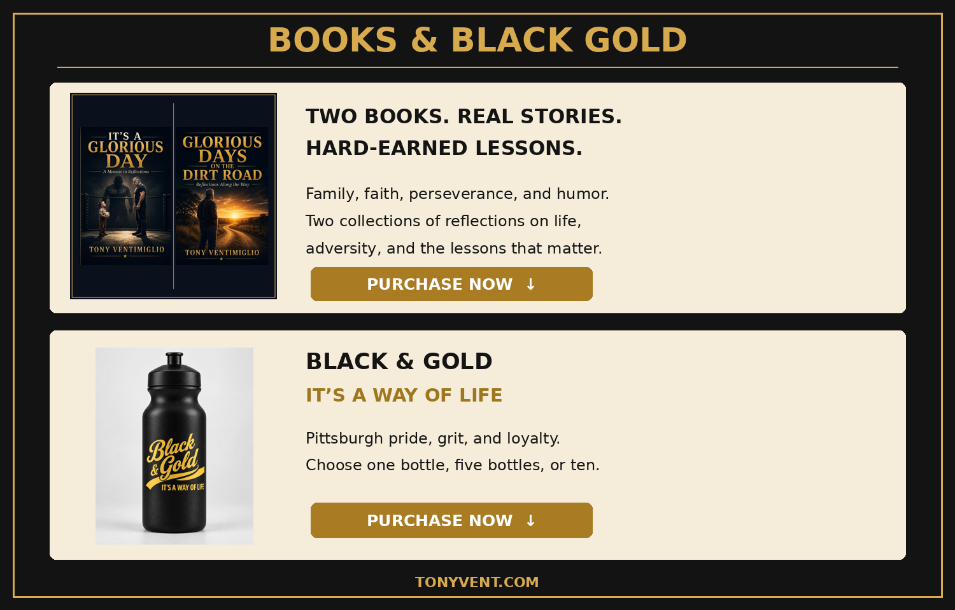

PROFESSIONAL RECOMMENDATIONS
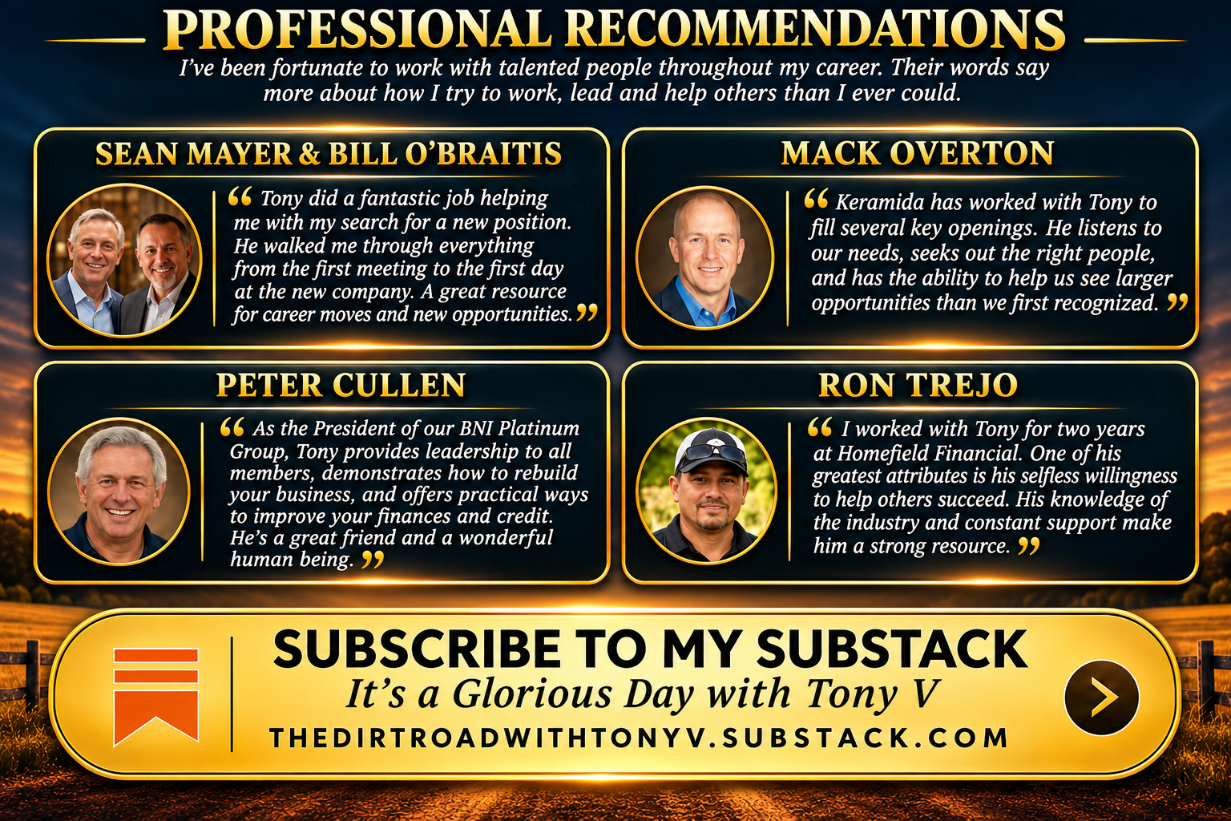

BOOK REVIEWS
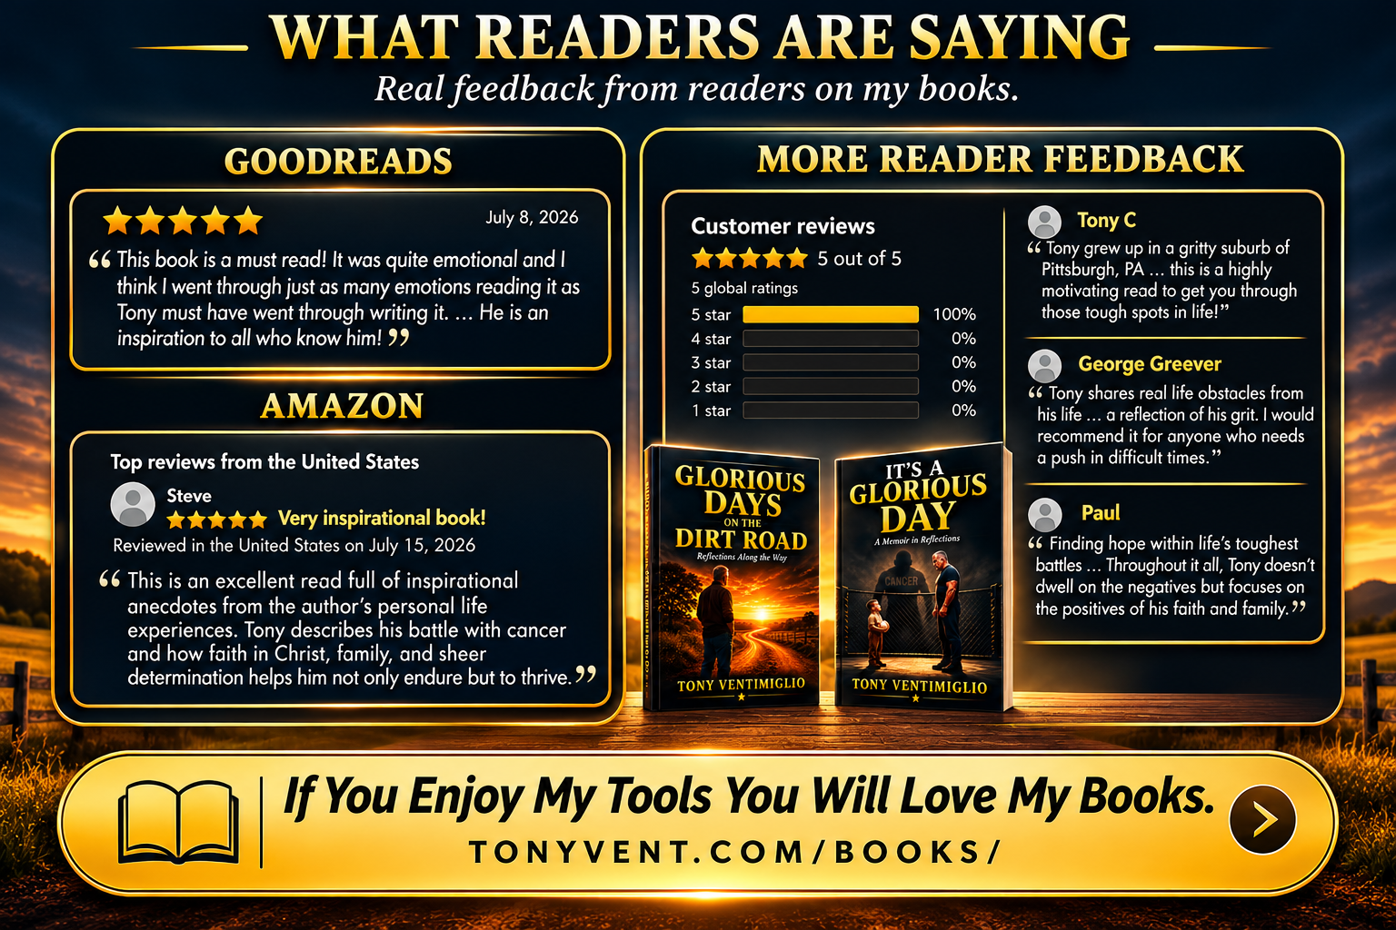

 | PODCAST HOST CONTACT & LINKS  Tony Ventimiglio  Author • Speaker • Business Leader

CONTACT & FEATURED RESOURCES | SOCIAL MEDIA & CONTENT
  Website
  TonyVent.com
  Linktree
  linktr.ee/tonyvent
  Podcast Guest Materials Folder
  Bio, headshot, logo and book covers — Google Drive
  Books by Tony Ventimiglio
  tonyvent.com/books
  Helping Businesses Grow
  tonyvent.com/crm.html
  Fundraising Made Easy
  tonyvent.com/community-support.html
  Recent Podcast Appearance
  thesocialchameleon.show/tony-ventimiglio
  Videos by Tony Ventimiglio
  tonyvent.com/videos
  Newsletter Signup
  substack.com/@tonyvgloriousday
  Facebook
  facebook.com/tventimiglio
  The Dirt Road With Tony V
  facebook.com/TheDirtRoadWithTonyV
  Threads with Tony V
  threads.net/@tonyiagd
  Tony Ventimiglio on X
  x.com/Tonyventimiglio
  Tony on YouTube
  youtube.com/channel/UCz_97Z446V5WWdD9CM0N3tg
  LinkedIn
  linkedin.com/in/tonyventiagd
All links are clickable • TonyVent.com

